Downforce without wings

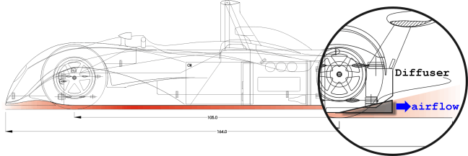

Fordonsaerodynamik
Institutionen för Termo-och Fluiddynamik
Chalmers Tekniska Högskola

2000-12-05

Yuping Li
Maria del Carmen Fernandez Visiedo
Hector Vallejo Paz
Luciano Rafael Bello de Aranaga
Index
1 Abstract 2
2 Why is downforce needed? 3
3 History 4
3.1 Spoil the flow 4
3.2 The Inverted Wing 4
3.3 Sealing skirts 5
3.4 The "Ground effect" era 5
3.5 Diffusing air 6
4 The Physics of Lift and Drag 7
4.1 Bernoulli 7
5 Vehicle Body Concepts 8
6 Downforce on the rear axle 10
6.1 Rear Spoilers 10
6.2 Diffusers 10
6.3 Downforce Generation Mechanisms in the Diffuser 12
7 Downforce on the front axle. 14
7.2 Air dams 15
7.3 Splitters 15
7.4 Dive plates 17
7.5 Wheel well gurneys 18
7.6 Louvers over front wheel 18
7.7 Front underbody contouring: undertrays 18
8 Downforce in the middle 21
8.1 Reducing inflow from the sides 21
8.2 The vacuum cleaner concept 21
8.3 Other uses of vortex lift 22
9 Relationships 23
10 References 24

Abstract
Motor sports are all about maximum performance, to be the fastest is the absolute. There is nothing else.
To be faster you need power, but there is a limit to how much power you can put on the ground. To increase this limit force must be applied on the wheels, increasing weight can do this, but weight makes handling worse. So we need some virtual weight, we call it downforce and get it from airflow around the car.
A wing can make a plane fly, but if we put it upside down, it can make a car NOT fly.
However, we can also achieve this without using wings. In this report we will explore how.
Basically we will not use wings, but try and make the whole car be a wing, and take advantage of what is called “ground effect” which makes wings much more effective on the ground. There are also plates, which if placed in the right place, will push the car down; we will talk about these near the end.
Downforce has to be balanced between front and rear, left and right. We can easily achieve the balance between left and right by simple symmetry, so it will not be discussed. Front and rear is a different thing. Flow in the front greatly affects flow in the back of the car, and vice versa. But to simplify the explanations, we will divide the car in three parts, front, middle and rear. Talk about what can be done in each part, and finally explain how part affects each other.

Why is downforce needed?
In current motor racing competitions, including Formula 1, Indy cars and Touring Car, aerodynamic downforce plays the most important role in the performance of the cars.
In the 1960's the use of soft rubber compounds and wider tires demonstrated that good road adhesion and hence cornering ability, was just as important as raw engine power in producing fast lap times.
The tire width factor came as something of a surprise. In sliding friction between hard surfaces, the friction resistance force is independent of the contact area. It came as a similar surprise to find that the friction could be greater than the contact force between the two surfaces, apparently giving a coefficient greater than one. This would be similar to having glue on the tires, making them “stick” to the ground.
The desire to further increase the tire adhesion led the major revolution in racing car design, the use of negative lift or 'downforce'. Since the tires lateral adhesion is roughly proportional to the downloading on it, or the friction between tire and road, adding aerodynamic downforce to the weight component improves the adhesion. Downforce also allows the tires to transmit a greater thrust force without wheel spin, increasing the maximum possible acceleration. Without aerodynamic downforce to increase grip, modern racing cars have so much power that they would be able to spin the wheels even at speeds of more than 160 ^{km}/_{hr}.

History

Spoil the flow
Up to the early 1960s, racecar engineers only focused on making car ‘streamlined’ and minimizing drag. However, as the vehicles became faster, they started to become very unstable, ensuring in spectacular accidents. After observations of these accidents they became aware that the streamlined cars in high speed were producing aerodynamic lift, in other words, they were trying to become airborne. This greatly reduced the grip available on the car, especially during high speed turning.
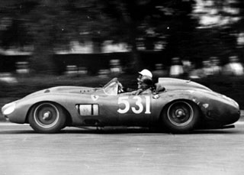
Figure 1, 1957 Ferrari 335 S. ¹
The first attempts to lessen the problem were by trying to disturb the flow, so that it would not be that of a wing profile. This lead to the use of "spoilers" which in many cases not only eliminated drag, but also contributed to the downforce. Another idea, also using spoilers, but in the lower portion, was to try and have most of the air flow on the upper part of the car, this was done by blocking the bottom front of the car with some kind of plate (front spoiler). The Ferrari 330 P3/4 was amongst the first competition cars to use them. In the picture the rear spoiler can be seen.
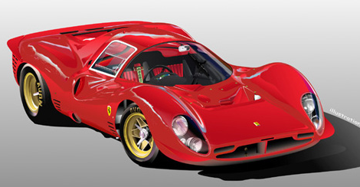
Figure 2, 1966 Ferrari 330-P4 ²

The Inverted Wing
The desire to further increase the tire adhesion led the major revolution in racing car design, the introduction of inverted wings, which produce negative lift or 'downforce'.
The first attempt to utilize an aerofoil on a racecar, but never in actual race, is thought to have been made by Michael May in 1956, on a Porsche Spyder. However, this car was prohibited from participating even before it reached the starting grid. The idea of using an inverted wing was forgotten for some ten years.
The aerodynamic downforce revolution actually started when the Chaparral 2D appeared in 1966. This car had controllable wing incidence, and won at Nurburgring. Then Chaparral 2E, which made Jim Hall be credited as the first racer to race a car with aerofoils, appeared at Bridgehampton in the same year. The controllable wing incidence was introduced to lower the drag produced by wings (by putting them in a horizontal position during long straight-aways).
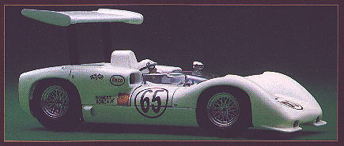
Figure 3, Chaparral 2E 3
Formula 1 soon followed, adding movable wings on the rear axle of the cars, soon followed by wings on the front to balance the car. Brabham introduced independently variable split wings, allowing control of the downforce on each corner. During 1968 many of the cars started using high mounted wings, and wings directly connected to the unsprung wheel assembly, so as not to affect the suspension.
These measures made wing structures extremely flimsy; therefore they were very susceptible to accidents, with some devastating effects. Wings were almost banned, but only allowed under stringent regulations. Very soon, all racing cars featured wings and spoilers for lift force reduction. 1970s saw gradual development and refinement of wings.
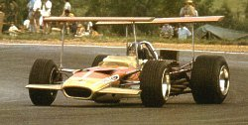
Figure 4, Lotus 49B ⁴

Sealing skirts
In 1969, the Chaparral 2J presented a special downforce concept: two large fans powered by motors were used to suck the car down onto the road firmly, while ‘skirts’ were used to seal the underside of the car from outside. Thus allowed the creation of low-pressure area below the car. But this was soon banned. Another approach, by fitting the car with an engine-cooling fan to create low pressure below the car, enabled Brabham to win in 1978 before it was prohibited. Because movable aerodynamic devices were not allowed in Formula 1 at that time, engineers tended to cleverly shape the car’s underside.
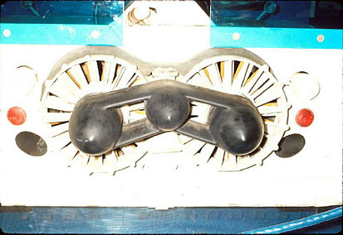
Figure 5, Fans of Chaparral 2J 5

The "Ground effect" era
The Lotus 78 was the first competitive ‘ground effect’ design. The underbody of it was shaped in such a way that creates a Venturi effect with the ground. Mario Andretti scored the first victory for the Lotus 78 in US GP West held in Long Beach in 1978. The Spanish Grand Prix was up next and the Lotus 78 proved the class of the field. The later Lotus 79 has similar design but more efficient.
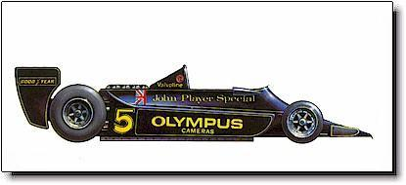 Figure 6, Lotus 79 6
Lateral skirts (also called ‘side-skirt’), which almost touch the ground, prevent air from flowing in from the sides. The wings enclosed by side plates were more effective than high-mounted or isolated wings.
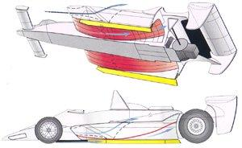
Figure 7, View of Lotus 79´s side pods. ⁶
The low pressure acted on the underbody creates high downforce to the cars, which means that suspension stiffness must be very high. This made the ride of the cars very rough and exerted great physical stress on the driver in the mean time. In addition, the downforce is so sensitive to the ground clearance and the gap between the skirts and the road surface, any sudden reduction in downforce produced by hitting a bump would cause the vehicle to leave track at high speed. Quickly, the lateral skirts were ruled out. But the ‘ground effect’ idea pervaded racing competitions all over the world wherever it was permitted.
Since 1983, the underbody panel between the wheels has been required to be completely flat in Formula 1, other formulas have also followed suit. Measures were taken to regain the downforce taken away by the changes in technical regulations, such as: powerful engines, effectively designed and positioned wings, etc.

Diffusing air
In 1989, designers reconsidered the underside of car while F1 cars returned to modest power levels. It was realized that with a sufficiently small ground clearance, and the right amount of nose-down attitude, a crude form of venturi section could be created beneath the cars in spite of the flat bottom. ‘Diffusers’, a section of gradually increasing area at the rear, was re-introduced to cause the air from the underside to escape as efficiently as possible at the rear of the cars. And the teams also produced cars with incredibly low ground clearance and even so called ‘active suspension’ system to help maintain a constant ride height. These active systems were later banned in Formula 1 and in many other categories.
Around 1994, further restrictions, which influenced the downforce producing, were introduced after some accidents. The ‘stepped underbody’ was among them. It was proved to effectively control the ground clearance and made the cars safer to drive.
Although rule makers always impose changes of regulation, designers and engineers have been doing their utmost to produce more downforce, improve performance and make cars as fast as possible. Fortunately, there are still many motor sports categories that permit the exploitation of downforce. So, we may see more practice involved in downforce in the foreseen future.
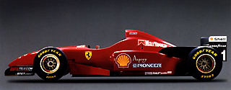
Figure 8, 1996 Ferrari F310 Formula 1 racecar. 7

The Physics of Lift and Drag

Bernoulli
Downforce is the opposite of aerodynamic lift; sometimes it’s referred to as negative lift. Aerodynamics, and therefore, lift have been studied from Aristotle to Bernoulli to actual times.
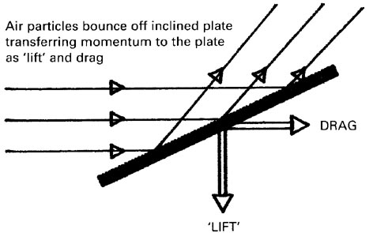
Figure 9, Newton’s theory of lift (downforce)8
Newton’s 1st law helps in understanding why lift and drag occur: air particles bounce off inclined plate transferring momentum to the plate as “lift” and drag:
Bernoulli’s equation is the basis on which much aerodynamic applications are based:
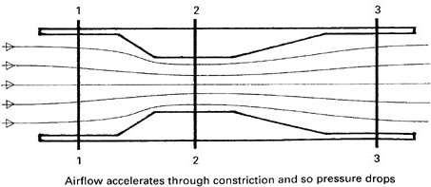
Figure 10, Schematic of a carburetor choke tube 9
This principle is the one that makes the venturi in a carburetor work. Air is drawn through the tube by the induction stroke of the engine. The flow velocity at line 2 is higher because of the reduced cross section area of the choke tube. Airflow accelerates through constriction and so pressure drops.
The two components of aerodynamic force are drag and lift.
These combine together to give the resultant total aerodynamic force, and this is the net effect of all the pressures acting upon a body, such as a wing. The pressure differences felt can be expressed mathematically as the pressure coefficient multiplied by dynamic pressure:
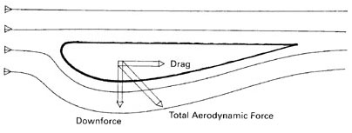
Figure 11, The two components of aerodynamic force 1⁰
We can also establish similar equations for lift and drag:
Where:
C_{L} = coefficient of lift C_{D} = coefficient of drag A = reference area
It is better to study it with some examples, as we are going to do later.

Vehicle Body Concepts
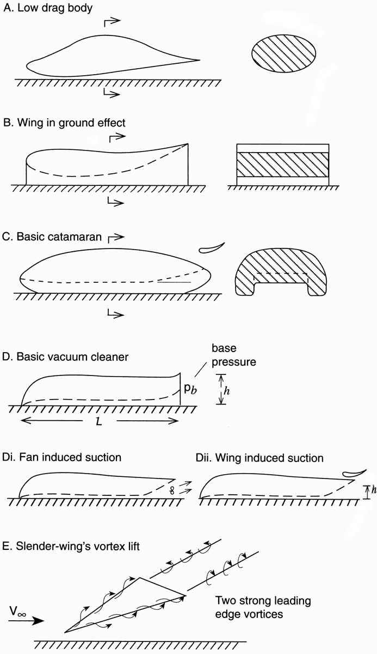
Figure 12, Body shapes that produce negative lift 1¹
The typical objectives of a good ground vehicle aerodynamic design are to reduce the drag and to increase the downforce (or at least reduce lift). A body’s generic geometry affects its aerodynamic lift and drag. In we can see some basic shapes that can create downforce without creating large drag force. -A shows the first generic shape. It’s aimed as a very low-drag configuration. The basic intention is to create a vehicle body with very low drag, and at the same time generate minimal lift or some downforce with the body. Speed record-breaking vehicles usually use this type of body shape, where there is no great need for downforce since the vehicle only has to drive in a straight line. -B shows an inverted wing in ground effect. What this means is that when a wing is near the ground, due to the limited space, the lift of the wing is greatly increased, this is called “ground effect”. The addition of side fins to seal the downforce from the sides considerably increases the downforce, since this makes the flow act as it was only 2D flow, not a 3D flow (where if could move to the sides of the wing), this increases the lift of the wing. -C shows the “catamaran” concept. It’s used in prototype racecars. The need to cover the wheels at the two sides of the vehicle resulted in a shape with a fairly high central tunnel ending with a moderate upward, rear slope (venturi). It reduces the area of flow separation on the back of the central body, creating an ideal high-downforce and low-drag configuration. -D shows a far more popular concept: the vacuum cleaner car. Most GTP cars have shapes similar to these. This shape will be explained in more detail later in the report. -E shows the inverted delta wing, this shape generates vortices that are responsible for the negative lift. What happens in this case is that the generated vortices move flow out from the low-pressure side of the wing, thus increasing the lift. This method is used when the shape is too small to generate enough lift by more conventional means. We can see this method in insects, whose wings are too small to generate the needed lift. The disadvantage of this shape is the drag penalty associated with it. This concept is also utilized in high performance aircraft, as on the F/A-18 shown, where one can see the vapor trails generated by the vortex extensions on each side of the cockpit.
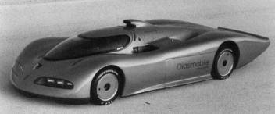
Figure 13, Oldsmobile Aerotech Aurora V8 land speed record car ¹²

Downforce on the rear axle

Rear Spoilers
A spoiler is a simple plate placed somewhere in the car body so that it can interfere or “spoil” the flow around the vehicle, creating a controlled separation of the flow in a desired place. This is done because fast, smooth airflow leads to positive lift, so by spoiling this flow the lift is either reduced or maybe completely canceled out.
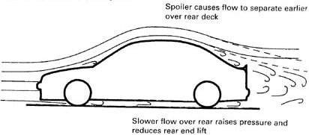
Figure 14, Effect of a rear spoiler ¹³
A rear spoiler is a plate in the rear of the vehicle, to be considered a spoiler, the plate must be integral with the body. If there’s a space between the plate and the body, then it it’s considered a wing. As can be seen in Figure 14 the spoiler causes separation in the rear of the car, creating turbulence just before the flow, this turbulence causes the flow to move more slowly, therefore reducing the low pressure in the area just in front of this spoiler. Therefore, lift on the rear portion of the car is eliminated. Properly designed, a rear spoiler will create downforce on the rear part of the car.

Diffusers
Diffusers are, after wings, the most commonly seen devices to generate downforce in the rear portion of the vehicle. In them, we use the Bernoulli equation, much in the same way that we do with a venturi tube. In a venturi, we can see clearly that pressure and velocity squared are inversely proportional, so diffusers can help to reduce the pressure of the flow by increasing its velocity.
We can compare the similarities between underbody flow (with a diffuser present) and the venturi flow using the next figures.
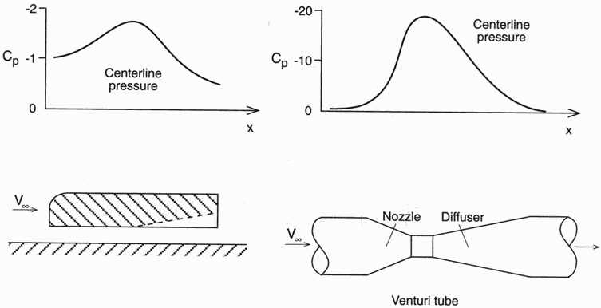
Figure 15, Comparisons of pressure distributions along a general body near the ground and a venturi tube ¹⁴

The left-hand figure shows the lower surface pressure distribution along the centerline of a generic body, the right-hand one shows the same using a venturi. The converging part of the venturi (nozzle) increases the flow speed and the diverging section (diffuser) reduces it. Both pressure distributions are very similar, and we can see that in both cases the lowest pressure is obtained at the narrowest flow passage, which in a ground vehicle can be utilized to generate downforce. That is why terms diffuser, venturi or underbody tunnel are synonymous.
Low ground clearance by itself will generate downforce, as long as the underside is smooth, of course. However, at the trailing end of the car, the accelerated flow will come into contact with slower speed flow coming from other parts of the vehicle, this will create a great amount of turbulence in the car’s wake. This turbulence will both add to the drag of the car and limit maximum downforce since it will not be as easy for the air under the car to come out through the rear.
A diffuser allows the airflow under the car to slow down to its original velocity in a smooth way, this way air can more easily move to the rear of the car. Since air can move more easily, it will actually move faster, so we will have an increase in downforce. Another benefit will be a decrease in drag, since the diffuser creates a less turbulent wake. The effect of diffuser angle on the CL value can be seen in the following graph.
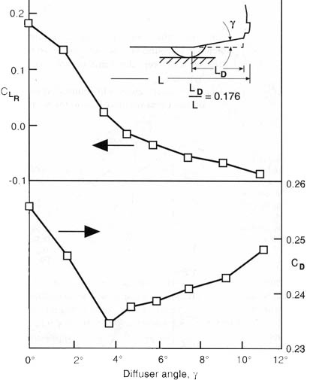

Figure 16, Effect of diffuser angle on C_{LR} (rear axle) and C_{D} 15
The lower surface of some racecars will have longitudinal, slanted underbody channels, instead of a neat inverted airfoil shape. Because of the low pressure created inside these channels, the flow from the sides of the vehicle (in between the front and rear wheels) enters the channels from the sides, if the sides are sharp, strong concentrated vortices will be formed, this is shown in Figure 17.
A true flat-bottomed car, without diffuser, can produce downforce using the same principle. To do this the car is run in rake, this means that the rear end is a little higher than the front. This way the underside becomes a large diffuser, with two suction peaks: one in the entrance, and the other at the trailing edge of the flat undertray.
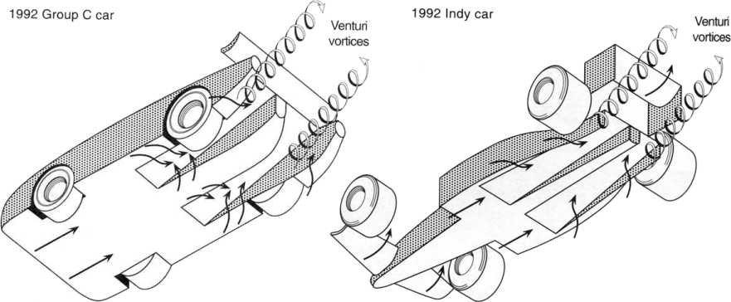
Figure 17, Typical underbody channels in two types of racecars ¹⁶

Downforce Generation Mechanisms in the Diffuser
It has been identified that there are three different downforce generating mechanisms for a vehicle body: underbody upsweep (body camber), ground interaction and diffuser pumping.

Upsweep
The presence upsweep on the rear underbody of an otherwise symmetrical body will camber the body, resulting in a downward-directed lift force, or downforce. The situation is exactly of an inverted fastback automobile.

Ground Interaction
In potential flow, a symmetrical body in free air has zero lift, however, as the body is brought into proximity with the ground, the flow becomes asymmetric. The flow beneath the body accelerates due to ground constraint. The accompanying reduction in underbody static pressure produces downforce on the body. The downforce increases with increasing proximity to the ground as clearance (ride height) approaches zero. This behavior is shown schematically in Figure 18.
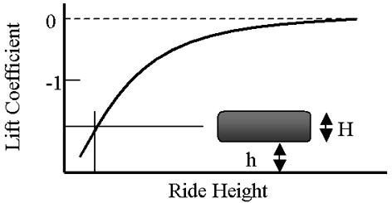
Figure 18, Schematic of Potential-flow Downforce Behavior ¹⁷

Diffuser Pumping
The diffuser in itself doesn’t produce a reduction in pressure. Its main function is to decrease the flow’s velocity from inlet to outlet (so that at the outlet the flow velocity is similar to the free stream velocity), with a corresponding increase in static pressure. This pressure rise can be used to increase the flow rate through a system, as was known even in Roman times. The diffuser can be considered to have “pumped-down” the underbody, inducing a component of downward force on the vehicle.
The pressure rise in the diffuser drives this process, so it is the pressure-recovery behavior of the diffuser that governs the influence on an automobile. This pressure rise is a function of the ratio of the areas at the outlet and the inlet diffuser, where this area ratio is set by the diffuser angle and the vehicle ride height.
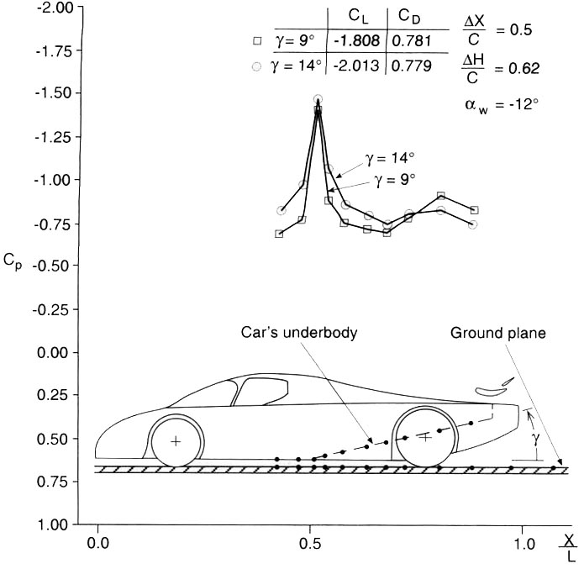
Figure 19, Effect of tunnel angle on centerline pressure distribution for a generic prototype racecar 18

The downforce can be improved by using small tabs at the rear of the long tail, as the next picture shows. That creates a small vortex that will help wake infill as well as produce a small amount of downforce on the surface. This idea can then be extended to the rest of the diffuser, so that the flow in the diffuser can be separated from the rest of the flow in the vehicle, this can be seen in Figure 20.
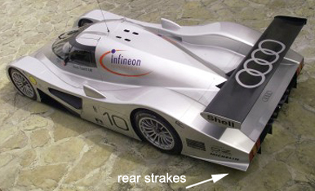
Figure 20, Audi R8C observe rear strakes

Downforce on the front axle.
It is relatively easy to obtain downforce on the rear of the car using a diffuser, as has already been explained. But to maintain proper control of the vehicle, it is necessary that the downforce on the vehicle be balanced as much as possible between the front and rear of the vehicle, in this part we’ll talk about of ways to get downforce in the front of the car.

Front Spoilers
Now let’s try and apply a spoiler to the front of the vehicle. Since lift is usually created by air going through the vehicle’s underside, we can place something to limit the flow of air through these areas; the object added to the front is called a spoiler or dam.
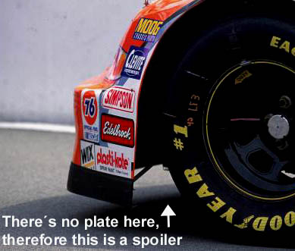
Figure 21, Front spoiler on a Nascar Chevrolet
The spoiler reduces the gap between the ground and vehicle blocking most of the air that would go under the vehicle (sending it to the sides of the car). If the spoiler is utilized on a car that doesn’t have a smooth underside, where the airflow is extremely turbulent, drag is greatly reduced since less air has to pass through all the elements in the bottom of the car, we can also expect to get a reduction in lift (and maybe a little downforce) in this case.
If the vehicle has a smooth underside, as would have to be if we want to have a rear diffuser the spoiler will actually increase the drag, since the flow underneath is not turbulent and we are increasing the frontal area. We can expect downforce to be generated since the wake of the spoiler creates an area of low pressure behind the spoiler, sucking the vehicle down. We must study the effect of the front spoiler on the rear of the vehicle, since there’s always the possibility that the spoiler doesn’t let enough air through for the diffuser to be effective.
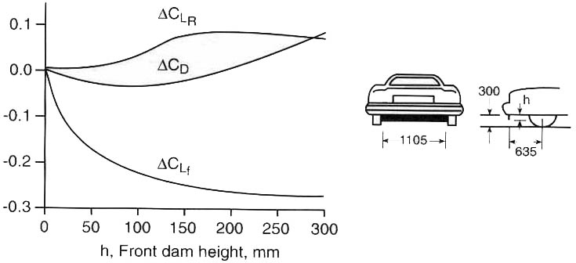
Figure 22, Effect on front spoiler height on lift and drag coefficients of a generic sedan automobile ¹⁹

Air dams
The spoiler creates a low-pressure area behind it by blocking flow of air to the underside, but also accelerates the air that does manage to pass. This accelerated air has a lower pressure. In an air dam we take advantage of this situation by creating an area for the low pressure to act on. The air dam is simply a horizontal plate that extends from the spoiler towards the rear of the car. The length of the air dam is usually limited by regulations.
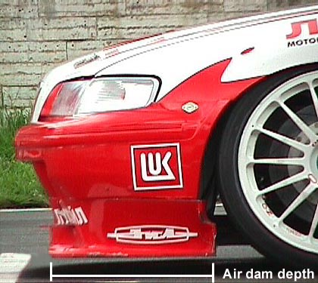
Figure 23, Honda Accord Super Touring car, detail of front air dam ²⁰

Splitters
In cars with a blunt nose there exists an area of stagnation, where the flow separates and goes in different directions. The pressure in this area is high; a splitter is designed to take advantage of this to generate some downforce. It is basically a plate added in front of the air dam, so it not only is pushed down by the stagnation area, but it also contributes to the air dam effect. This greatly increases the downforce, while at the same time creating no excess drag, since there is no increase in the frontal area of the car.
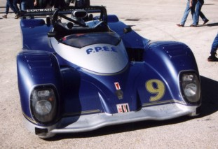
Figure 24, Anhedrally shaped splitter on a Courage C41 21
The splitter should not be extended too much forward of the vehicle, not only would it then become a hazard to other drivers, but the splitter doesn’t generate any downforce if there’s no high pressure above it, i.e., the length of the splitter is limited by the size of the high pressure area in front of the car.
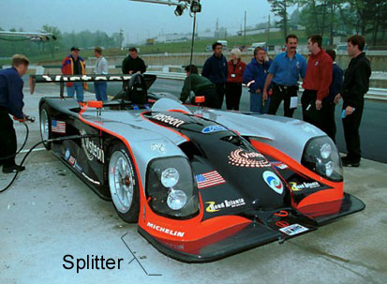
Figure 25, Panoz LMP1 Roadster, observe huge splitter 22
Splitters are useless in cars with a very streamlined front (like the solar racers and such), since there’s not a large enough high-pressure stagnation zone to push the splitter down with noticeable force.
The lower the car is to the ground the greater suction that will be created by the ground effects, therefore the splitter is usually located at the lowest possible point. However if the splitter is too close to the ground it will stall, producing less downforce and more drag (exactly the opposite of what’s desired). This is because air will not be able to go trough the bottom part of the splitter, so the speed of the flow there (on the bottom part) will decrease, increasing the pressure.
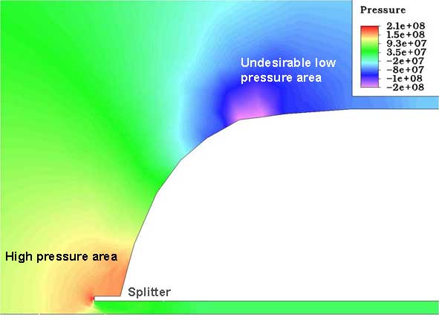
Figure 26, CFD of front of a generic sports car. Observe high-pressure area on which splitter works

From this we can see that a splitter can be very sensitive to ride height. In order to remove this sensitivity we use different heights on the splitter, in other words, an anhedral shape. This solution has the advantage that in the case that the car touches the ground, part of the splitter will continue to create downforce.
Splitters are not only used in closed wheel cars, Formula 1 cars use a slightly different splitter on the underside of the high nose (Figure 27). Splitters are also found in front of the rear tires of open wheel cars, taking advantage of the stagnation zone that exists there (see Figure 28).
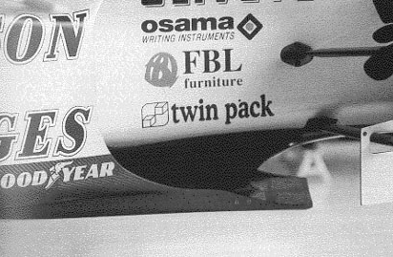 | 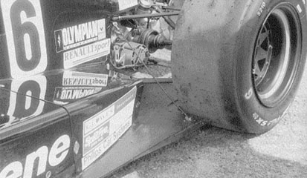
Figure 27, Jordan F1 car, underside splitter located just behind front wheels. 23 | Figure 28, Splitter behind rear tire ²³

Dive plates
Using the principle of vortex lift on slender wings, we can create downforce. This is done using inverted delta wing shapes (see Figure 29). In the front of the car, dive plates utilize this principle.
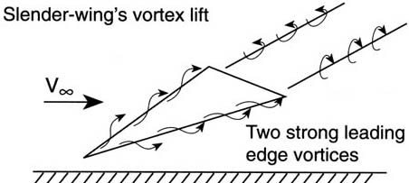
Figure 29, Separation of flow in a slender wing ¹¹
These small fin like attachments to the front corners of the car. The inclination of these plates creates downforce on the front of the car, though the amount is not that much.
The same devices can be used in other parts of the vehicle; however, care must be taken so that the leading edge vortices do not affect the operation of the rear wing or other aerodynamic devices.
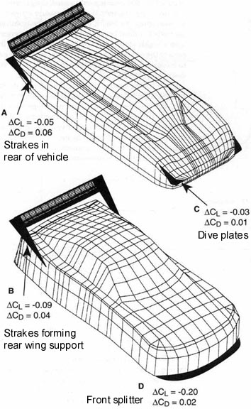
Figure 30, Representative effect of the use of flat aerodynamic devices on lift and drag ²³
This dive plates are more trimming devices than anything else, they are too small to generate large amounts of downforce; instead, they are used to set up the vehicle handling before a race.
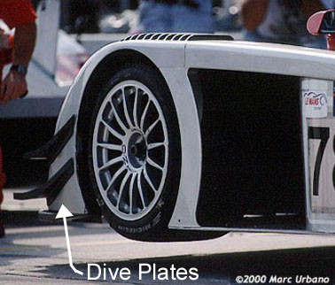
Figure 31, Audi R8 see twin dive plates on front corner 24

As can be seen in Figure 30, the use of flat plates (that is splitters, dive plates and strakes) can have considerable effect on the downforce obtained, while obtaining a minimal drag penalty.
In this figure we see the main application for each type of plate, and the approximate values of downforce and the associated drag penalty. As can be seen, the rear strakes generate a considerable amount of drag for the downforce they generate; this is why we don’t find them in many vehicles. The splitter is the most important element of the 3 shown, since the downforce/drag ratio is around 10, which is very good.

Wheel well gurneys
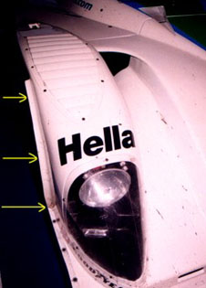
Figure 32, Mazda Kudzu, wheel gurney indicated by arrows ²⁵
Small metal strips located around the front wheel well. These create a slight vacuum behind them by forcing the flow away from the side of the vehicle, the effect being that the high pressure generated inside the wheel well due to the rotation of the wheel is reduced. Since some part of this pressure would act on the upper part of the well, we obtain a reduction of lift (though no downforce). A secondary effect is better wheel brakes cooling, though this is better achieved by directing air from the under plate toward the brake.

Louvers over front wheel
In Figure 32 we can see a series of vents on the upper part of the wheel well, these have 2 main functions, the most important one being cooling of the brakes, by giving the hot air a rather easy path of exit, at the same time they reduce the pressure inside the wheel well, eliminating any lift that might be created due to the wheel rotation.

Front underbody contouring: undertrays
LMP cars have a flat bottom, but the front of the car can have ducts to feed the engine and such. These ducts are used also to gain a certain downforce. As you can see in the following image of a Toyota GT-One the front underside of the vehicle is highly contoured, so that air coming under the car splits up, some of it going through to the rear of the car, but another part goes to the exits behind the front wheel. This flow, goes upward into a diffuser like compartment, called an undertray, where it’s pressure is reduced, thus generating downforce just ahead of the front axle. The effect is basically the same as an air dam, but here the flow is also directed towards the sides and the splitter that marks the beginning of the flat floor.
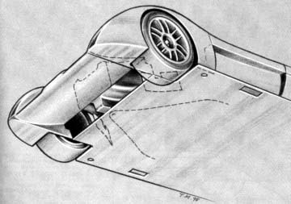
Figure 33, Underside of Toyota GT-One 26
Looking at the diagram shown in Figure 34 it can be seen that the car’s front is very similar to a wing in ground effect, even though looking at the vehicle there is no wing present. This design is not as effective as a "real" wing due to the redirection of flow. However, the fact the sides are relatively sealed increases the effect of the shape.
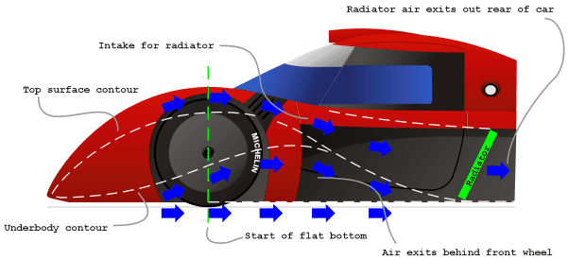
Figure 34, Diagram of the front of a Toyota GT-One car. Observe how the dotted lines make up a wing contour ²⁶

In the next pictures, we can see different ways of handling the airflow in the front of the vehicle, here the designers of the vehicle are trying to achieve the same thing: more front end downforce by giving the air a place to expand and thus reduce pressure.
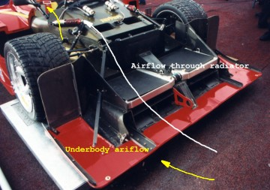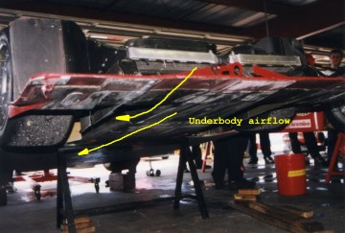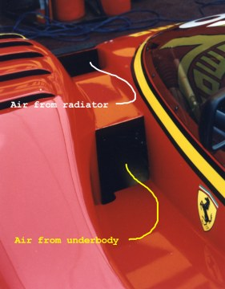
Figure 35, Views of the front of a Ferrari SP333 Sports Car. See comments explaining path of the flow ²⁷

Sucking air with undertrays
Coming back to the vacuum cleaner concept, the front undertray can be made is such a way that a "sucking" design in used to cool the engine, while at the same time obtaining downforce, the best example of this would be the Lola B98/10 and it’s developments. By not having the engine cooling intakes in the upper or front part of the vehicle, the shape obtained produces much less drag than a more conventional design, a secondary, but very important side effect is that the engine intakes create a sucking effect, thereby creating a near vacuum in the bottom part of the vehicle (specially true in the area just around the intake). This allows the car to have the rear wing at a higher more efficient point relative to the car, since we do not need it to achieve the "sucking" effect.

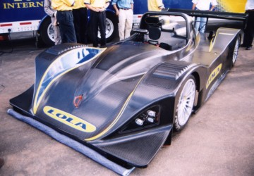  Figure 36, Lola B98/10, observe the lack of cooling intakes. The light colored strip in the front is a cloth ²⁸ | 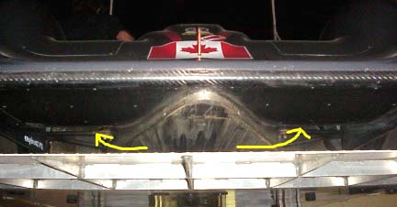  Figure 37, Undertray of a Lola B98/10, the arrows show how the air under the car is sucked into the engine cooling intakes. ²⁹

The great disadvantage of this design is limited cooling, especially when the ground is hot (in this case the air is warm, no cooling is obtained!) and the possibility of ingestion of foreign objects into the radiator (lots of dirt, rocks, etc). To eliminate the cooling problem either air from another source has to be mixed before going into the radiator. A rather complex solution was used in the following generation Lola (B2K/10).
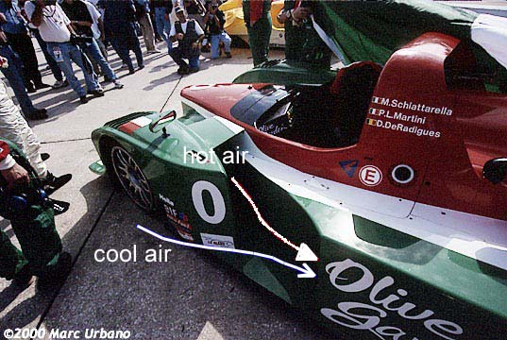
Figure 38, Lola B2K/10, the hot air from the undertray is mixed with cooler air from the side of the car before entry into the engine ³⁰

Downforce in the middle
We talked about how downforce can be created in the rear and the back, now we will talk about how to increase it in the middle of the car.

Reducing inflow from the sides
These devices are designed to prevent flow in the sides of the vehicle from being sucked into the bottom of it. They are basically plates that are in contact with the ground, but can move up and down to allow suspension travel. See Figure 40. This greatly increases the effect of the front spoiler’s work by not letting the air from the sides fill the low-pressure areas underneath the vehicle. A more thorough explanation follows in the next section.
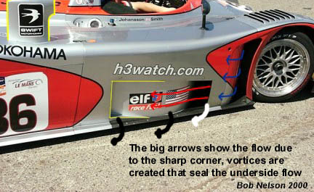
Figure 39, Reynard 2KQ showing sharp bottom ³¹
A skirt is not needed to achieve this effect. Having sharp edges on the lower sides of the vehicle body makes, as shown in Figure 39, creates vortices that basically "seal" the bottom of the car from the rest of the flow. This solution is usually used since skirts are banned in most formulas, also, a skirt can get stuck in the up position, creating a potentially dangerous situation.

The vacuum cleaner concept
This concept has already been explained. In this section we explain it in more detail, since the parts that make up the concept have already been explained.
If we extend the side skirts and front spoiler so that we can prevent most of the flow from going into the bottom of the car, we will get a very low pressure in the bottom of the car. If the rear section of the car is left open, this low-pressure area will be maintained (since there’s flow separation in the rear of the car). This solution yields a lift/drag ratio (L/D ratio) of around the same value as the length/height ratio of the vehicle.
Improving on this concept, a fan can be added in the rear of the car that sucks air from under the rear of the vehicle, creating a vacuum there. At the same time the sucked air is expelled on the back of the vehicle, filling the low pressure area created by the flow separating from the body, this reduces the vehicle’s drag. This idea was utilized by the Chaparral 2J shown in Figure 40, but was rapidly banned.
Since the use a fan is usually outlawed, an inverted wing, placed very close to the rear opening (usually it would be a diffuser), will create a low-pressure area that would have about the same effect, i.e. it would suck the air from underneath the car.

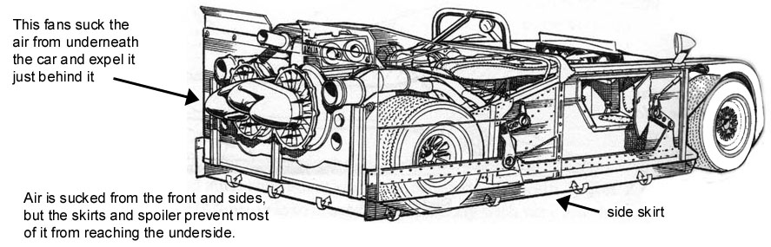
Figure 40, 1969 Chaparral 2J - First car to utilize the fan aided vacuum cleaner concept ³²

Other uses of vortex lift
This principle can also be utilized on other parts of the body, for more substantial effects. Although usually incurring a large drag penalty, if properly designed, strakes in the body can create vortices with minimal drag that give some increase in the vehicles negative C_{L}.
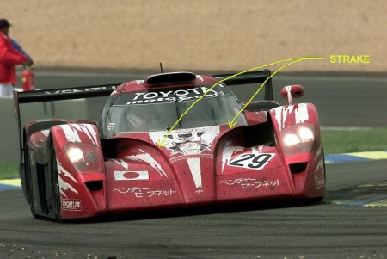
Figure 41, Toyota GT-1, see strakes in front of cockpit 33
In the Toyota GT-1 there are strakes than run almost the whole width of the car just in front of the cockpit. These strakes will generate vortices along the sides of the cockpit; therefore, as the vortex gets bigger, they will fill the area just behind the cockpit. This increases the pressure there, reducing drag.
The same vortex will also fill the low-pressure area that forms in the middle outer sections of the car, reducing the inherent lift in that section.
The use of vortex lift in this manner is not very common, due to the little information available on the behavior of vortices at low subsonic speed.
However, with more research we can expect these features to become common in a few years.

Relationships
Flow cannot be divided, what happens in one-part affects what happens in another. Therefore, a front spoiler will affect a rear diffuser and vice versa.
Front spoilers are used to reduce flow to the bottom of the car; this is very desirable when the car does not have a smooth underside with a diffuser or other arrangement, simply for the drag reduction obtained. However, if we have a flat underside, it is actually worse to have a spoiler in the front. The smooth underside requires a rather big amount of air to be really effective, so a spoiler here would most surely not be desired. However, there are cases where we can see some small spoiler applied, the reasons for it can go to some specific aerodynamic design feature to simple ignorance.
A diffuser is used to increase flow rate in the bottom of the car, since there is a limit into how much air we can suck down there from the front, air will try and come from the sides, some times we can use this to our advantage, sometimes we don’t. This is why some cars use skirts.
We usually do not talk about wings in this report, since we are trying to avoid their use. However in practically all classes of racecars, we can find a rear wing. This is due to their easy adjustability, something that is impossible with an underbody. So we are probably going to have a wing, this wing has to receive rather steady flow for it to work, so we must be careful that the car body is able to provide it. Also, the wing will affect the performance of a diffuser, if it is close enough. This is desirable, since the wings effect is usually to increase the rate flow from the diffuser to the car’s wake.
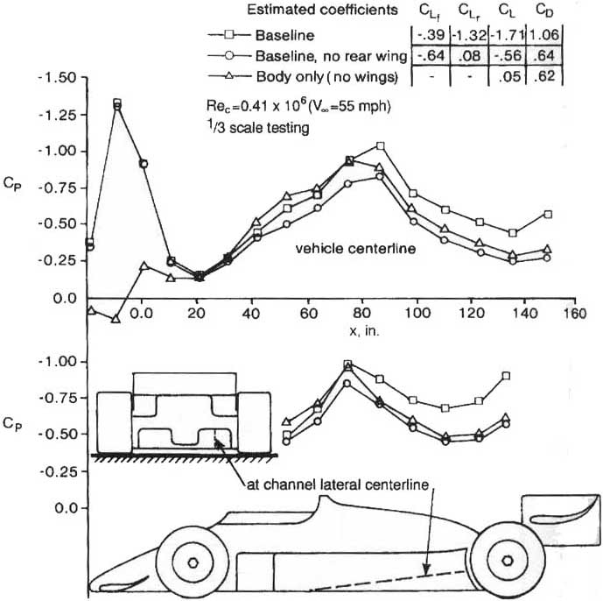
Figure 42, Effect of rear wing on an open wheel racecar’s underbody pressure distribution ³⁴

References
^{1, 7} http://www.ferrariturbo.co.uk/
² http://www.ferrari.it
^{3, 5, 6} http://www.ultimatecarpage.com/
⁴ http://www.f1nutter.com/
^{8, 9, 10, 13, 23} Competition Car Downforce: A Practical Handbook. Simon McBeath. Haynes Publishing 1999. ISBN:1859606628.
¹⁷ The Aerodynamic Performance of Automotive Underbody Diffusers. K.R. Cooper, T. Bertenyi, G. Dutil, J. Syms, G. Sovran. SAE 980030, International Congress and Exposition, Detroit, MI, USA, Feb. 1998. www.sae.org
11, 12, 14, 15, 16, 18, 19, 23, 32, 34 Race Car Aerodynamics: Designing for Speed. Joseph Katz. Bentley Publishers 1995. ISBN:0837601428. page 184
²⁰ http://www.auto-motorsport.ru/
21, 22, 24, 25, 26, 27, 28, 29, 30, 31, 33 http://www.mulsannescorner.com/

